Global Biotech Week Saskatchewan
Biotech, Science and Art: A Collaboration with Nuit Blanche
September 25, 2021 – After Dark
River Landing, Traffic Bridge

Karlie King BA, (2003); MA, (2006); PhD, (candidate 2006-2008)

Karlie has received a variety of grants and awards, including a Social Sciences and Humanities Research Grant, Saskatchewan Arts Board Indigenous Pathways Initiative Grant and Independent Arts Grant.

Her work has been featured in numerous solo and group exhibitions across the country. She currently teaches at The Cathedral School of Art (Regina, SK), is Curator at Hague Gallery (Regina, SK), and is a dedicated mother of two.
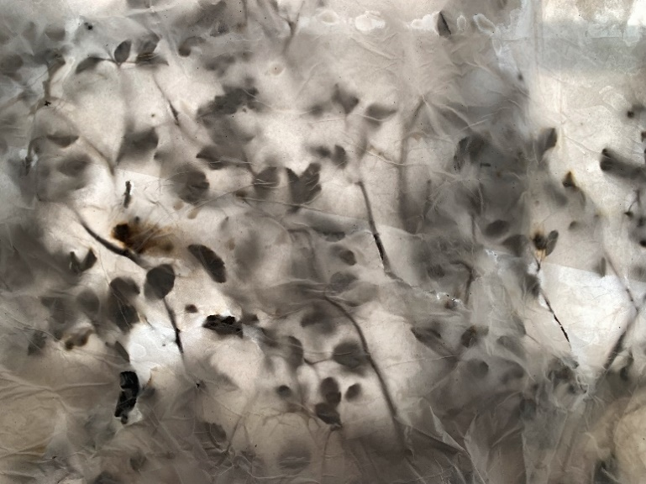
Artist Statement: A Moveable Forest

How many hundreds of hours have I spent picking Saskatoons? How many glorious hours in the quiet, being warmed by the sun, in meditative practice (without knowing I was meditating), picking one-by-one. No distractions. Just the sound of the breeze through the trees, or the odd rustle from a rabbit or squirrel, and the birds chirping.

Like all things, the berries follow cycles, and some years they would be like grapes, while other years you really had to work to fill a bucket.

I’ve frozen Saskatoons, canned them, turned them into jelly. But my favourite is just eating them by the handful after they have just been picked - when my fingertips are already stained purple, and they are still warm from the Sun.

I’ve heard all about the benefits of Saskatoons - how they clean the blood, how they are antioxidants, the various minerals, and vitamins they contain. How they have literally sustained entire communities through harsh winters, and such. They are such a phenomenal little berry.

I don’t get to the forest much anymore. I don’t get to pick the sacred Saskatoon berry as much as I did before. But that forest moves with me everyday. The solitary practice of berry picking still forms how I move through this world. It dictates much of my personality and demeanour. And the nutrients still keep my blood clean and nourish my body and mind. It’s still all there, inside me, emanating from me, moving with me as I navigate this life.

